**Software Engineering Tools Lab**

**Assignment No-8**

**PRN: 2020BTECS00055**

**Name:Shreeshail Mahajan Batch: T7**

----------------------------------------------------------------------------------------------------

# Q 1. What are the prerequisites for installing the TestLink tool.

Q 2. Install TestLink tool on your machine (Provide screen shots for successful installation and login)

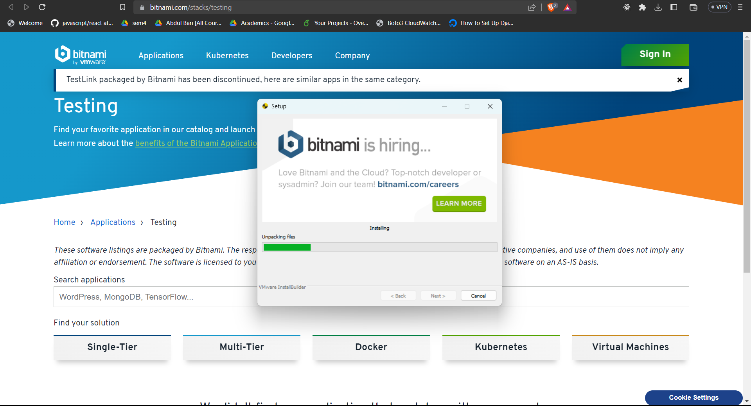

Q 3. Using TestLink tool create multiple test cases (at least 10) on any application/project that you have implemented.

Perform below tasks

1. Create New test project as SETProject

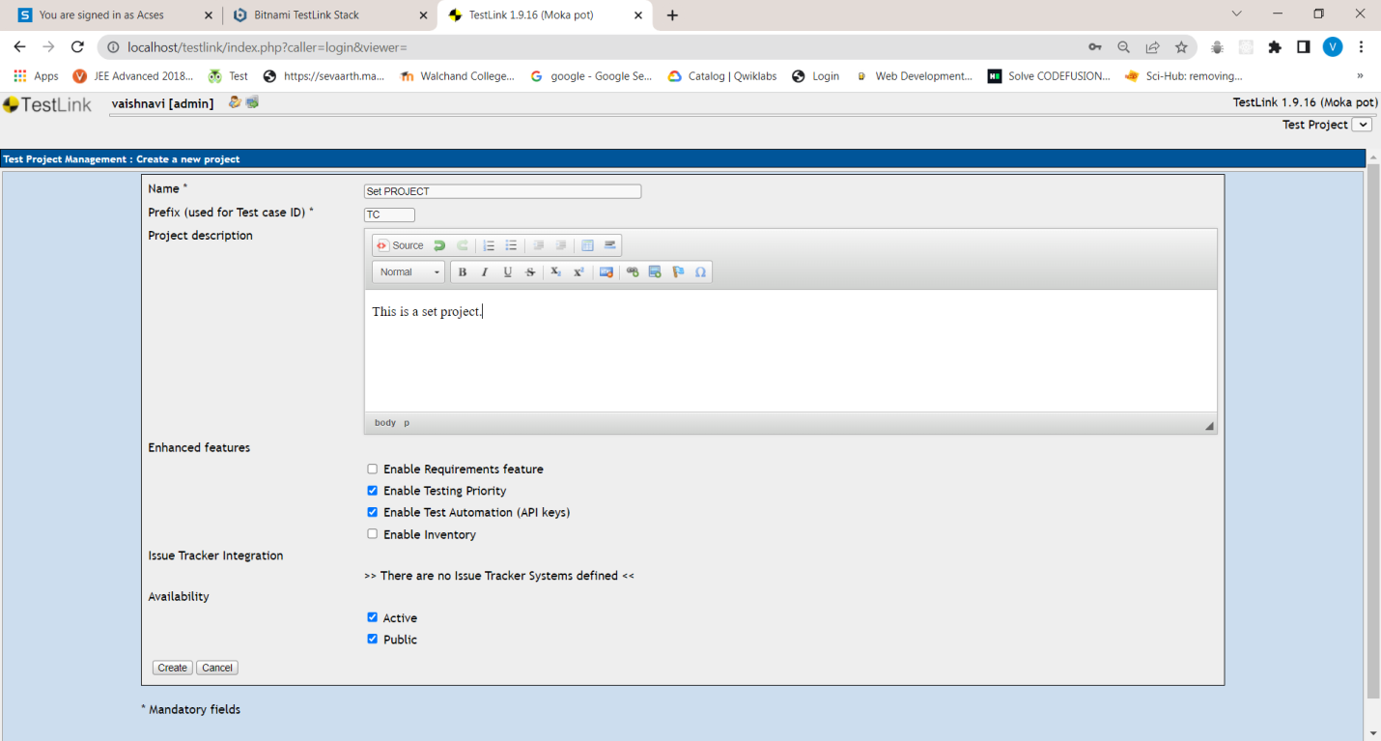

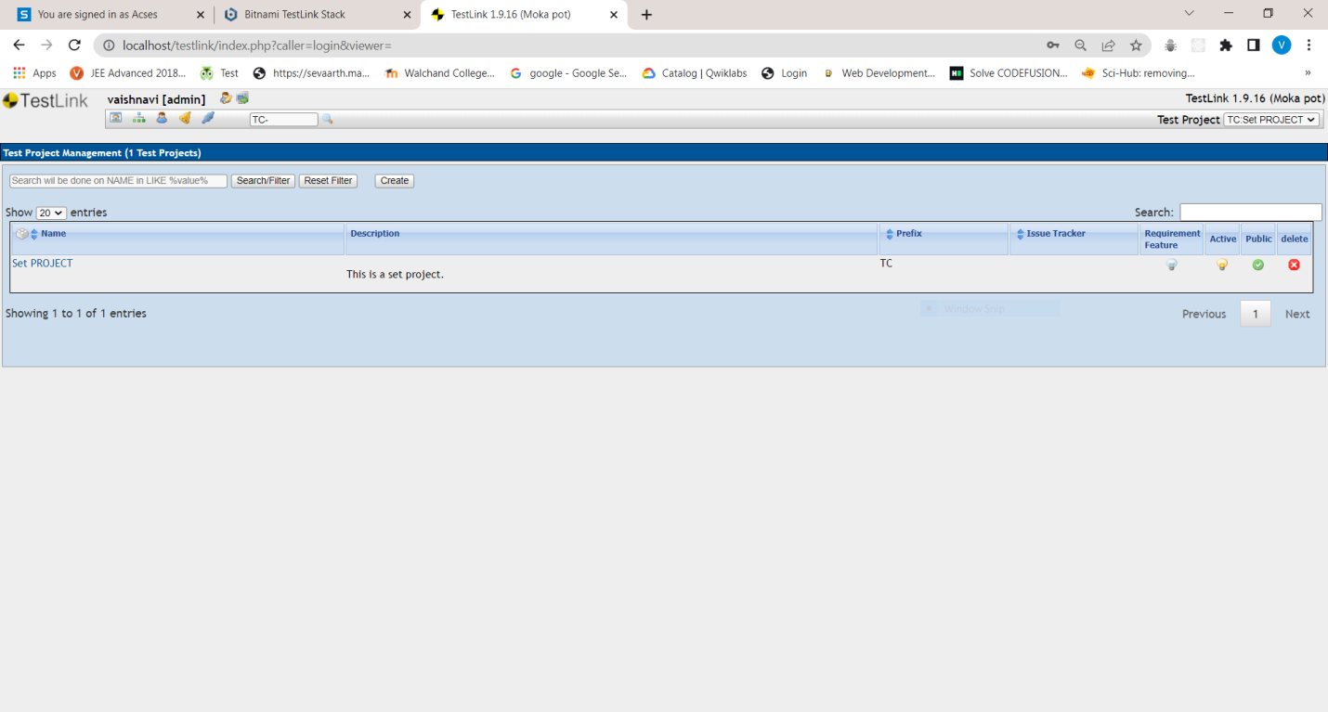

1. Create a test plan as SETProjectTestPlan

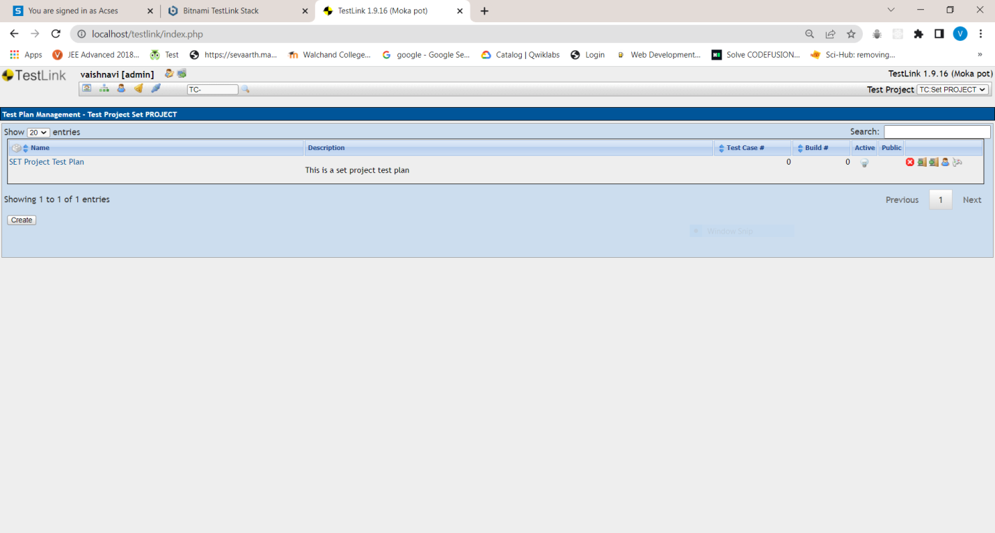

1. Create a build as SETProjectBuild

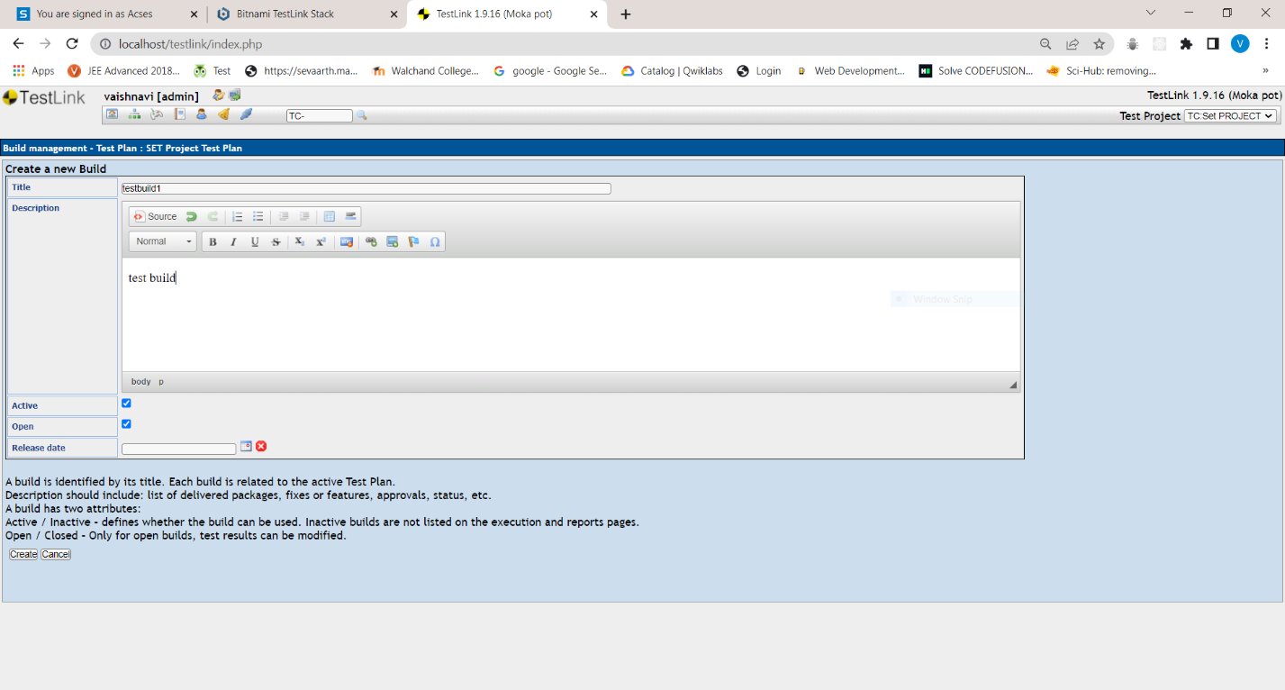 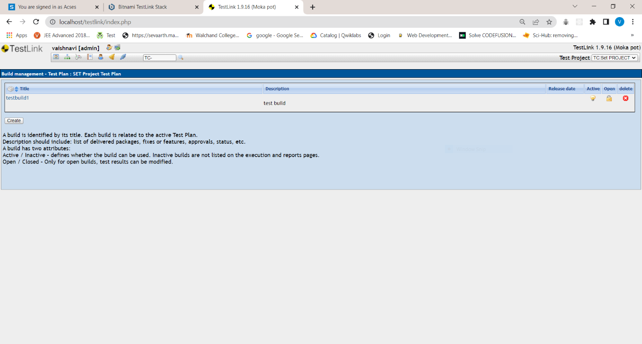

1. Create test suite as Test Suite 1 under SETProject

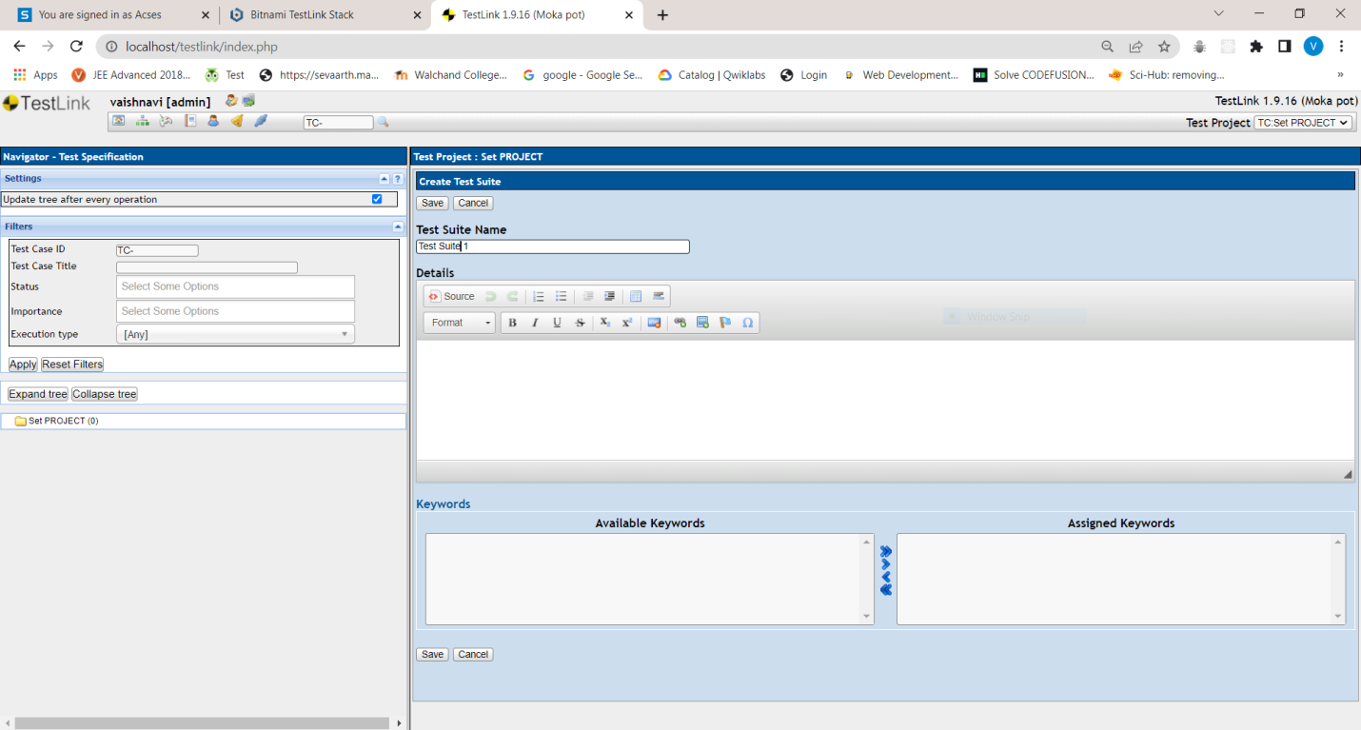 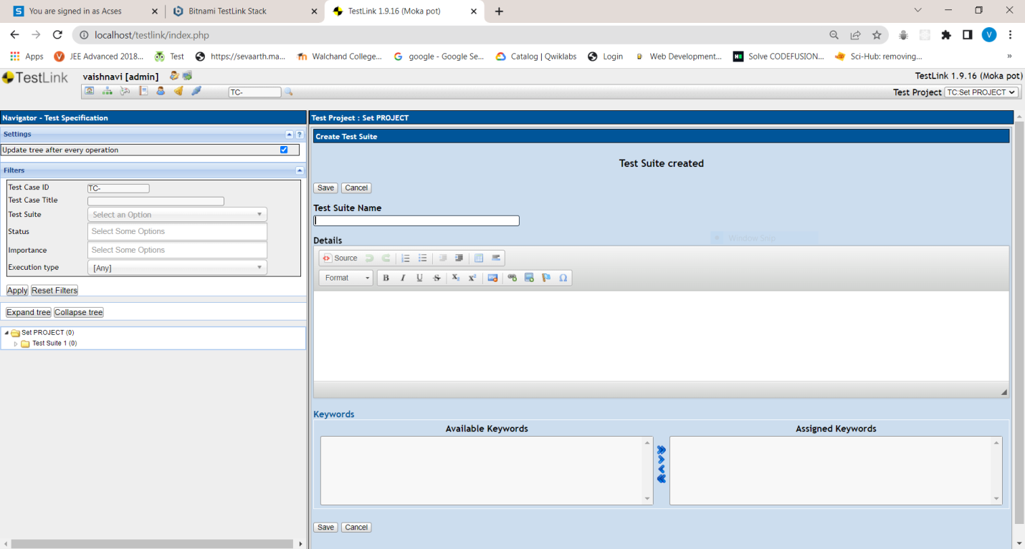

1. Create Test cases in TestLink Tool

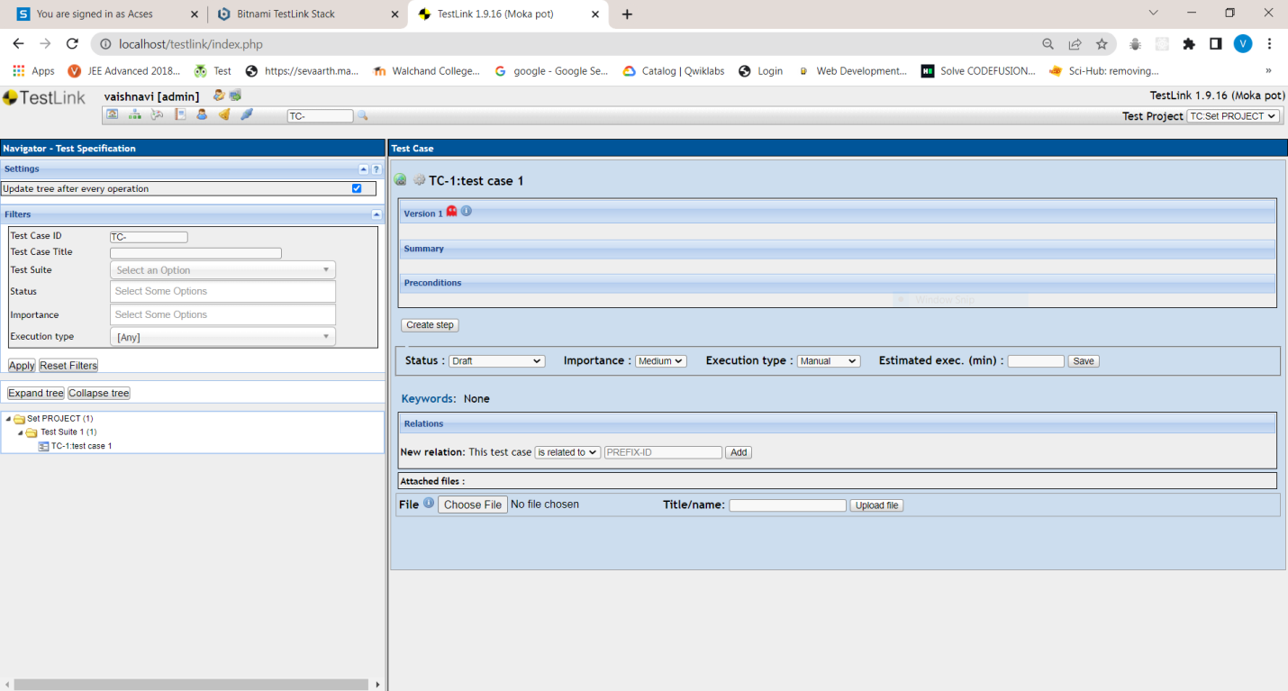

1. Assigncreated Test Cases to the test plan SETProjectTestPlan

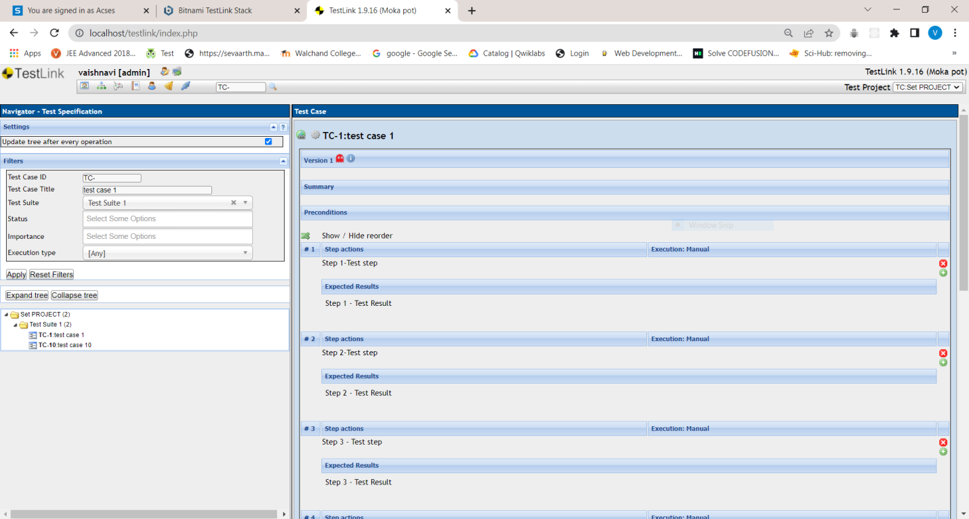

1. Create different roles as given below in the TestLink

|  |  |  |  |
| --- | --- | --- | --- |
| **S No.** | **Role** | **Test Cases** | **Test Metrics** |
| 1. | Guest | View | View |
| 2. | Tester | Execute | View |
| 3. | Senior Tester | Edit & Execute | View |
| 4. | Leader & Admin | Edit & Execute | Edit & Execute |

1. Write a requirements in TestLink
2. Executetest cases
3. Generate a test report in excel format.